BLOCKCHAIN-BASED E-TENDER MANAGEMENT SYSTEM
MICRO PROJECT REPORT

Submitted by
RANJANI M REGISTER NO.: 24UCS189
LAKSHMIPRIYA R REGISTER NO.: 24UCS122
SHIYONA THILAK REGISTER NO.: 24UCS228
YUVASRI S REGISTER NO.: 24UCS289

Under the guidance of
Mrs. V. INDUMATHY
in partial fulfilment of the requirements for the degree
of
BACHELOR OF TECHNOLOGY

DEPARTMENT OF COMPUTER SCIENCE AND ENGINEERING
SRI MANAKULA VINAYAGAR ENGINEERING COLLEGE
MADAGADIPET, PUDUCHERRY - 605107
OCTOBER 2026


Affiliated to PONDICHERRY UNIVERSITY

DEPARTMENT OF COMPUTER SCIENCE AND ENGINEERING

BONAFIDE CERTIFICATE

This is to certify that the micro project work entitled “BLOCKCHAIN-BASED E-TENDER MANAGEMENT SYSTEM” is a bonafide work done by RANJANI M [24UCS189], LAKSHMIPRIYA R [24UCS122], SHIYONA THILAK [24UCS228], YUVASRI S [24UCS289] in partial fulfilment of the requirement, for the award of B.Tech Degree in Computer Science and Engineering by Pondicherry University during the academic year 2026-2027.

PROJECT GUIDE HEAD OF THE DEPARTMENT
Mrs. V. INDUMATHY Dr. N. DANAPAQUIAME
Assistant Professor Professor & Head

INTERNAL EXAMINER EXTERNAL EXAMINER

ACKNOWLEDGEMENT

We are very thankful and grateful to our beloved guide, Mrs. V. INDUMATHY whose great support in valuable advices, suggestions and tremendous help enabled us in completing our project. She has been a great source of inspiration to us.

We also sincerely thank our Head of the Department, Dr. N. DANAPAQUIAME whose continuous encouragement and sufficient comments enabled us to complete our project report.

We thank all our Staff members who have been by our side always and helped us with our project. We also sincerely thank all the lab technicians for their help as in the course of our project development.

We would also like to extend our sincere gratitude and grateful thanks to our Director cum Principal Dr. V. S. K. VENKATACHALAPATHY for having extended the Research and Development facilities of the department.

We would like to express our faithful and grateful thanks to our Chairman and Managing Director Shri. M. DHANASEKARAN for his support.

We would like to thank our Secretary Dr. K. NARAYANASAMY for his constant support

We are pleasure to thank our Treasurer Shri. D. RAJARAJAN and our Joint Secretary Shri.S. VELAYUDHAM for their great support.

We wish to thank our family members and friends for their constant encouragement, constructive criticisms and suggestions that has helped us in timely completion of this project.
Last but not the least, we would like to thank the ALMIGHTY for His grace and blessings over us throughout the project.

ABSTRACT

The rapid growth of digital technology has changed the way government organizations handle purchasing and contract-related activities. E-procurement and e-tendering systems have made it easier for government departments to publish tenders, receive bids, and select contractors through online platforms. However, managing a tender does not end with selecting a contractor. Proper monitoring of the project, payments, progress, and contractor performance is also important to ensure that public funds are used appropriately. This project focuses on developing a Government Tender Lifecycle Management System that aims to improve transparency, security, and monitoring throughout the tender process.

Existing government e-procurement platforms mainly focus on activities such as publishing tender notices, collecting bids, evaluating bids, and awarding contracts. Although these systems have made the tendering process faster and more organized, many activities after tender allocation still depend on manual verification and monitoring. Information is generally maintained through centralized systems, and tracking the actual progress of a project, delays, cost overruns, and contractor performance can be difficult. Existing research on blockchain-based e-tendering has also mainly focused on securing the bidding and tender allocation process, with limited attention given to continuous project monitoring and risk prediction after the contract is awarded.

The proposed system combines Hyperledger Fabric blockchain, smart contracts, and machine learning to manage the tender process from creation to project completion. Hyperledger Fabric will be used to maintain secure and tamper-evident records of important tender transactions, while smart contracts will automate activities such as bid validation, eligibility checking, tender allocation, and milestone-based payment authorization. Machine learning will be used to analyze contractor and project-related data to predict risks such as project delays, cost overruns, and contractor reliability. The system will also provide project progress and milestone tracking for better monitoring by government officials. By combining blockchain for transparency and secure record keeping with machine learning for risk prediction, the proposed system aims to provide better decision support, improve accountability, and make the overall tender lifecycle more transparent and efficient.

LIST OF TABLES

TABLE NO. | NAME OF THE TABLE | PAGE NO.
2.1 | Comparison of Reviewed Research Papers | 17
3.1 | Existing System and Proposed System Comparison | 21
4.1 | Hardware Requirements | 23
4.2 | Software Requirements | 23
4.3 | Technology Stack | 24
5.1 | System Modules and Functions | 31
5.2 | Machine Learning Input Features | 32
6.1 | Database Tables and Purpose | 35
6.2 | Blockchain Transactions | 39
6.3 | Machine Learning Model Performance | 40
6.4 | System Test Cases | 42
A.1 | Major Backend APIs | 44
A.2 | Smart Contract Functions | 45
A.3 | Sample Risk Prediction | 46
B.1 | Final System Testing Summary | 54

LIST OF FIGURES

FIGURE NO. | NAME OF THE FIGURE | PAGE NO.
5.1 | System Architecture | 27
5.2 | System Workflow | 29
6.1 | Government Dashboard | 37
6.2 | Tender Management Interface | 37
6.3 | Machine Learning Prediction Dashboard | 42
B.1 | Login Screen | 49
B.2 | Government Dashboard | 50
B.3 | Tender Creation Screen | 50
B.4 | Tender Listing Screen | 51
B.5 | Bid Submission Screen | 51
B.6 | Bid Evaluation Screen | 52
B.7 | Blockchain Transaction Output | 52
B.8 | Smart Contract Transaction Output | 53
B.19 | Machine Learning Risk Prediction | 53
B.10 | Project Monitoring and Verification Screen | 54
B.11 | Audit and Transaction History | 54

LIST OF ABBREVIATIONS

Abbreviation | Expansion
AI | Artificial Intelligence
API | Application Programming Interface
CGPA | Cumulative Grade Point Average
CSS | Cascading Style Sheets
DBMS | Database Management System
ER | Entity Relationship
HD | High Definition
HTML | HyperText Markup Language
ID | Identifier
IoT | Internet of Things
JSON | JavaScript Object Notation
ML | Machine Learning
RAM | Random Access Memory
SSD | Solid State Drive
UI / UX | User Interface / User Experience

TABLE OF CONTENTS
CHAPTER NO. | TITLE | PAGE NO.
 | ABSTRACT | 4
 | LIST OF TABLES | 5
 | LIST OF FIGURES | 6
 | LIST OF ABBREVIATIONS | 7
1 | INTRODUCTION | 10
 | 1.1 E-PROCUREMENT | 10
 | 1.2 E-TENDERING | 10
 | 1.3 GOVERNMENT TENDER MANAGEMENT | 11
 | 1.3.1 Tender Creation and Publication | 11
 | 1.3.2 Bid Submission and Evaluation | 12
 | 1.3.3 Tender Award and Contract Management | 12
 | 1.4 TENDER LIFECYCLE MANAGEMENT | 12
 | 1.5 BLOCKCHAIN TECHNOLOGY | 13
 | 1.5.1 Blockchain in E-Tendering | 13
 | 1.6 MACHINE LEARNING IN PROJECT MONITORING | 14
2 | LITERATURE SURVEY | 15
 | 2.1 PAPER-I – BLOCKCHAIN-BASED E-TENDERING SYSTEM | 15
 | 2.2 PAPER-II – BLOCKCHAIN-BASED E-TENDERING EVALUATION FRAMEWORK | 16
 | 2.3 PAPER-III – DECENTRALIZED TENDERING OF CONSTRUCTION PROJECTS USING BLOCKCHAIN-BASED SMART CONTRACTS AND STORAGE SYSTEMS | 17
 | 2.4 COMPARISON OF THE STUDIED PAPERS | 18
 | 2.5 RESEARCH GAP | 18
 | 2.6 SUMMARY | 19
3 | SYSTEM STUDY | 20
 | 3.1 EXISTING SYSTEM | 20
 | 3.1.1 Existing Government E-Tendering Process | 20
 | 3.1.2 Issues in Existing System | 21
 | 3.1.3 Limitations of Existing System | 21
 | 3.2 PROPOSED SYSTEM | 21
 | 3.2.1 Objectives | 22
 | 3.2.2 Advantages | 22
 | 3.3 FEASIBILITY STUDY | 23
 | 3.3.1 Technical Feasibility | 23
 | 3.3.2 Operational Feasibility | 24
 | 3.3.3 Economic Feasibility | 24
4 | SYSTEM REQUIREMENTS | 25
 | 4.1 HARDWARE REQUIREMENTS | 25
 | 4.2 SOFTWARE REQUIREMENTS | 26
 | 4.3 TECHNOLOGY REQUIREMENTS | 26
 | 4.3.1 React.js | 27
 | 4.3.2 FastAPI | 27
 | 4.3.3 PostgreSQL | 27
 | 4.3.4 Hyperledger Fabric | 28
 | 4.3.5 Machine Learning | 28
 | 4.3.6 Docker | 28
 | 4.4 SUMMARY | 28
5 | SYSTEM DESIGN AND MODULES | 29
 | 5.1 SYSTEM ARCHITECTURE | 29
 | 5.2 SYSTEM WORKFLOW | 33
 | 5.3 GOVERNMENT/ADMIN MODULE | 34
 | 5.4 CONTRACTOR MODULE | 35
 | 5.5 TENDER MANAGEMENT | 36
 | 5.6 BID SUBMISSION AND EVALUATION | 36
 | 5.7 BLOCKCHAIN MODULE | 37
 | 5.8 SMART CONTRACT MODULE | 37
 | 5.9 MACHINE LEARNING MODULE | 38
 | 5.9.1 Contractor Risk Prediction | 39
 | 5.9.2 Project Delay Prediction | 40
 | 5.9.3 Cost Overrun Prediction | 40
 | 5.10 PROJECT MONITORING | 41
 | 5.11 MILESTONE AND PAYMENT MANAGEMENT | 42
 | 5.12 AUDIT AND RECORD MANAGEMENT | 42
 | 5.13 SUMMARY | 43
6 | IMPLEMENTATION AND TESTING | 44
 | 6.1 DATABASE IMPLEMENTATION | 44
 | 6.2 BACKEND IMPLEMENTATION | 45
 | 6.3 FRONTEND IMPLEMENTATION | 45
 | 6.4 HYPERLEDGER FABRIC IMPLEMENTATION | 46
 | 6.5 SMART CONTRACT IMPLEMENTATION | 47
 | 6.6 MACHINE LEARNING IMPLEMENTATION | 48
 | 6.6.1 Contractor Risk Prediction | 49
 | 6.6.2 Project Delay Prediction | 49
 | 6.6.3 Cost Overrun Prediction | 49
 | 6.7 MACHINE LEARNING RESULTS | 49
 | 6.8 PROJECT MONITORING IMPLEMENTATION | 50
 | 6.9 MILESTONE AND PAYMENT IMPLEMENTATION | 50
 | 6.10 SYSTEM TESTING | 51
 | 6.11 RESULTS AND DISCUSSION | 51
 | 6.12 SUMMARY | 52
7 | APPENDIX – I | 53
8 | APPENDIX – II | 59
9 | CONCLUSION AND FUTURE ENHANCEMENT | 63
 | REFERENCES | 65

CHAPTER 1
INTRODUCTION

1.1 E-PROCUREMENT
E-procurement refers to the use of electronic systems and digital technologies for purchasing goods, services, and works from external suppliers or contractors. In government organizations, procurement is an important process because a large amount of public money is involved in purchasing materials, awarding construction projects, and obtaining different types of services. Traditional procurement processes involved a large amount of paperwork, physical document handling, and manual verification, which could make the process time-consuming and difficult to monitor.
The development of information technology has made it possible to perform many procurement activities through online platforms. E-procurement systems allow government departments to publish requirements, invite suppliers or contractors, receive bids, evaluate submitted information, and manage contracts electronically. This reduces paperwork and provides a more organized method for handling procurement activities.
E-procurement can also improve accessibility because contractors can view available tenders and submit their bids through an online platform. Digital records make it easier for authorized officials to retrieve information related to tenders, contractors, and contracts. However, procurement does not end when a contractor is selected. The progress of the project, payments, completion of milestones, and contractor performance also need to be monitored throughout the project lifecycle.
Therefore, an effective e-procurement system should not only support the tendering process but should also provide better visibility and accountability throughout the complete tender lifecycle.

1.2 E-TENDERING
E-tendering is an important part of e-procurement in which tendering activities are conducted through an electronic platform. Government departments can publish tenders containing project requirements, estimated costs, eligibility conditions, submission deadlines, and other terms. Registered contractors can view tenders and submit their bids electronically.
The major activities include tender creation, publication, contractor registration, bid submission, evaluation, contractor selection, and tender award. Electronic systems reduce manual paperwork and organize tender-related information. However, tendering mainly focuses on contractor selection, while project execution requires monitoring progress against the agreed schedule and budget. Delays, cost increases, incomplete work, and differences between planned and actual progress must be identified early.
In the proposed project, e-tendering serves as the starting point of the complete tender lifecycle. The system extends beyond bid submission and tender allocation to include project monitoring, risk prediction, milestone tracking, and payment-related activities.

1.3 GOVERNMENT TENDER MANAGEMENT
Government tender management covers the complete process of creating, publishing, evaluating, awarding, and monitoring government contracts. It begins when a department identifies the need for a work, service, or material and prepares the required tender documents.
The tender is published for eligible contractors to submit bids. These bids are evaluated based on predefined conditions, technical requirements, financial aspects, and contractor eligibility. After evaluation, a suitable contractor is selected, and the contract is awarded.
After the award, the contractor must execute the project according to the contract conditions. Government officials verify milestones, inspect work, approve progress, and authorize payments. Maintaining proper records throughout the process is therefore essential.
The proposed system divides tender management into different stages and maintains records for each stage. Blockchain technology stores important transaction records, smart contracts enforce predefined rules, and machine learning analyzes contractor and project data to predict risks and support monitoring and decision-making.
1.3.1 Tender Creation and Publication
Tender creation is the first major stage of the tender management process. At this stage, the government department defines the requirements of the project. Important details such as tender ID, project name, estimated budget, eligibility requirements, submission deadline, project duration, and other conditions are entered into the system.
After the tender is created, it is published through the electronic platform. Registered contractors can view the tender details and determine whether they are eligible to participate.
In the proposed system, important tender information can be recorded on the blockchain so that the stored record can be verified later. Smart contracts can also be used to check predefined conditions related to the tender. This provides a structured and secure way of managing tender information.
1.3.2 Bid Submission and Evaluation
After a tender is published, eligible contractors can submit their bids before the specified deadline. The bid may contain information such as the proposed bid amount, contractor experience, previous project details, and other required documents.
The submitted bids need to be evaluated according to the rules and conditions specified in the tender. Contractor-related information can also be considered during evaluation. In the proposed system, machine learning can be used to analyze historical contractor and project information and generate risk-related predictions.
The ML model does not replace the final decision of the authorized government officials. Instead, it provides additional information that can help officials understand possible risks related to a contractor or project.
1.3.3 Tender Award and Contract Management
Once the bid evaluation process is completed, the tender is awarded to the selected contractor according to the applicable rules. Details of the awarded tender and contract can then be recorded in the system.
Contract management continues after the tender is awarded. It includes monitoring project execution, checking milestones, recording progress, and managing payments according to the contract conditions.
In the proposed system, blockchain can provide a permanent and verifiable history of important contract-related transactions. Smart contracts can also support predefined conditions for activities such as milestone completion and payment authorization. This helps maintain a clear record from tender award until project completion.

1.4 TENDER LIFECYCLE MANAGEMENT
Tender lifecycle management refers to managing a tender from its initial creation until the completion of the project. Instead of considering tendering and project execution as separate activities, the complete lifecycle connects all major stages of the process.
The major stages of the tender lifecycle considered in this project are:
Tender Creation → Tender Publication → Bid Submission → Bid Evaluation → Tender Award → Project Execution → Progress Monitoring → Milestone Verification → Payment Authorization → Project Completion
Each stage generates important information that may be required for future verification and auditing. Maintaining these records properly is important because government projects involve public resources.
The proposed system aims to connect these stages through a common platform. Blockchain is used for maintaining important transaction records, while smart contracts help enforce predefined rules. Machine learning is used during contractor and project analysis to identify possible risks such as delays and cost overruns.
Project monitoring is particularly important after the tender is awarded. A contractor may receive approval for a particular budget and schedule, but the actual project may experience delays or additional costs during execution. Therefore, monitoring project progress and identifying potential risks early can help government officials take appropriate action.

1.5 BLOCKCHAIN TECHNOLOGY
Blockchain is a distributed digital ledger technology that records transactions in a way that makes records difficult to alter without detection. Instead of storing information in a single central database, it maintains records across authorized participating nodes in a network.
A blockchain consists of blocks containing transaction information, with each block linked to the previous one using cryptographic techniques. This creates a chronological transaction record. When a new transaction is added, participating nodes validate and record it according to the network's rules.
Blockchain is useful in government tender management because multiple parties, including government departments, contractors, finance departments, and auditing authorities, are involved. Recording important transactions on a blockchain provides a common record that authorized participants can verify.
This project uses Hyperledger Fabric, a permissioned blockchain framework in which network participants are known and authorized, making it suitable for government procurement.
The proposed system uses blockchain to record tender creation, bid submission, tender awards, project milestones, payment-related transactions, and project completion. Large documents and files need not be stored directly on the blockchain; instead, relevant metadata or file hashes can be recorded when required.
1.5.1 Blockchain in E-Tendering
Blockchain can be applied to different stages of the e-tendering process. When a tender is created, important details can be recorded as a blockchain transaction. Similarly, bid submission and tender award events can be recorded to maintain a history of activities.
One of the important advantages of using blockchain is maintaining the history of transactions. Once a transaction has been recorded and committed to the blockchain ledger, it is not normally edited like a regular database record. If a change is required, a new transaction can be recorded, allowing the history of activities to be maintained.
In the proposed system, Hyperledger Fabric provides the blockchain infrastructure, while smart contracts, known as chaincode in Hyperledger Fabric, define the rules for processing tender-related transactions.
For example, a smart contract can check whether a bid is submitted before the deadline or whether a contractor satisfies predefined eligibility conditions. Similarly, milestone-related conditions can be used before recording payment authorization.
Therefore, blockchain provides the secure record-keeping layer of the proposed system, while smart contracts provide rule-based transaction processing.

1.6 MACHINE LEARNING IN PROJECT MONITORING
Machine learning is a branch of artificial intelligence that allows computer systems to learn patterns from available data and use those patterns to make predictions. In government project management, historical contractor and project information can be analyzed to identify factors that may be associated with project risks.
In the proposed system, machine learning is used mainly as a decision-support component. Data such as tender value, bid amount, contractor experience, previous project delays, previous cost overruns, project duration, and other relevant project information can be used as input features.
Based on the available dataset, the system can be developed to predict risks such as:
- Contractor reliability risk
- Project delay risk
- Cost overrun risk
For example, if historical project data shows that projects with certain characteristics frequently experienced delays, the machine learning model can identify similar patterns in a new project and provide a risk prediction.
The prediction is intended to assist authorized officials in monitoring projects and identifying areas that may require attention. It should not automatically determine whether a contractor is guilty of misconduct or make the final government decision.
The combination of machine learning with blockchain provides two different functions in the proposed system. Blockchain focuses on secure and traceable record keeping, while machine learning focuses on analyzing data and predicting possible project risks. Together, these technologies support the objective of managing and monitoring the government tender lifecycle from tender creation to project completion.

CHAPTER 2
LITERATURE SURVEY

2.1 PAPER-I – BLOCKCHAIN-BASED E-TENDERING SYSTEM
Dhawal Mali, Divya Mogaveera, Parth Kitawat, and Mohd. Jawwad presented “Blockchain-based e-Tendering System” at the 2020 4th International Conference on Intelligent Computing and Control Systems (ICICCS). The paper explores blockchain and smart contracts to improve the security, transparency, and reliability of electronic tendering. It addresses concerns in traditional e-tendering systems, including data security, transparency, and maintaining reliable audit trails.
The proposed system uses smart contracts on the Ethereum blockchain and divides tendering into four stages: tender creation and publishing, bidding, bid evaluation and negotiation, and winning-bid selection. Smart contracts automate activities according to predefined rules, reduce unnecessary manual intervention, and maintain traceable and verifiable transaction records.
The paper demonstrates how blockchain can improve trust among tendering participants by integrating smart contracts into different tendering stages. Its main contribution is providing a foundation for applying blockchain to government and construction-related tendering processes.
This research helps establish how smart contracts can automate tender-related activities and maintain trustworthy transaction records. However, it primarily focuses on tendering, evaluation, and bid selection rather than post-award activities such as project execution, milestone monitoring, delay prediction, cost monitoring, and payment tracking. The proposed project addresses this gap by extending tendering towards complete project lifecycle management.

2.2 PAPER-II – BLOCKCHAIN-BASED E-TENDERING EVALUATION FRAMEWORK
Xingbo Gong, Xingyu Tao, Moumita Das, Yuhan Liu, and Jack Cheng presented “Blockchain-based E-tendering Evaluation Framework” at the 38th International Symposium on Automation and Robotics in Construction (ISARC 2021). The paper examines problems with centralized databases in tendering, including data tampering, limited traceability, transparency issues, and manual involvement in tender evaluation. It explores blockchain as a reliable and traceable solution for managing evaluation activities.
The authors developed a blockchain-based tender evaluation framework incorporating tendering smart contracts to support evaluation operations and process tender-related information. The framework's feasibility was demonstrated through a tender evaluation example, showing its potential for practical application.
The paper emphasizes traceability because tender evaluation involves multiple activities and participants. Blockchain maintains transaction histories for verification and auditing, while smart contracts can reduce manual involvement and apply predefined evaluation rules.
This research provides useful insights for the proposed project, particularly regarding smart contracts in bid evaluation and traceable tender records. However, it primarily focuses on the tender evaluation stage rather than the complete lifecycle from tender creation to project completion. It does not specifically address continuous project monitoring, machine learning-based risk prediction, milestone verification, or post-award payment monitoring. The proposed project extends this approach by integrating blockchain-based tender management with machine learning and post-award project monitoring.

2.3 PAPER-III – DECENTRALIZED TENDERING OF CONSTRUCTION PROJECTS USING BLOCKCHAIN-BASED SMART CONTRACTS AND STORAGE SYSTEMS
Salar Ahmadisheykhsarmast, Sina Golmohammadi Senji, and Rifat Sonmez presented “Decentralized Tendering of Construction Projects Using Blockchain-Based Smart Contracts and Storage Systems,” published in Automation in Construction in 2023. The paper proposes a decentralized blockchain-based tendering system to improve transparency, security, and trust while reducing dependence on centralized systems.
The system uses smart contracts to manage tender information, bid bonds, bid evaluation, and contract awarding. It also incorporates decentralized storage for tender documents and a decentralized application for participant interaction. By automating tendering rules and supporting multiple activities, the system demonstrates how blockchain can manage the tendering process beyond recording individual transactions.
The paper's use of decentralized storage is relevant because tender documents may not be suitable for direct blockchain storage. Separating document storage from blockchain transaction records provides a practical way to manage information while maintaining transaction verification.
This research is useful for the proposed project because it demonstrates how smart contracts, decentralized applications, and storage systems can support blockchain-based tender management. However, its main focus is tendering and contract awarding, rather than post-award activities such as continuous project monitoring, contractor performance analysis, delay and cost-overrun prediction, milestone verification, and payment tracking.
The proposed project extends these concepts to the complete tender lifecycle, including project execution and monitoring. Blockchain maintains secure, traceable records, while machine learning analyzes contractor and project information to predict risks related to contractor reliability, project delays, and potential cost overruns. This supports risk-based decision-making beyond the tendering and contract-awarding stages.

2.4 COMPARISON OF THE STUDIED PAPERS
The reviewed papers demonstrate that blockchain can improve transparency, traceability, security, and trust in tendering systems. The first paper focuses on Ethereum smart contracts for e-tendering, the second develops a blockchain-based tender evaluation framework, and the third presents a decentralized construction tendering process using smart contracts and decentralized storage.
However, these studies mainly focus on tendering and contract awarding, with comparatively less attention to post-award activities. After a project is awarded, continuous monitoring is necessary to ensure that work progresses according to the planned schedule, budget, and milestones.
This research gap guides the proposed project, which extends beyond secure tender creation, bidding, and contractor selection to cover the complete tender lifecycle, including project execution and monitoring.
Table 2.1 – Comparison of Reviewed Research Papers
Paper | Main Focus | Technology Used | Major Contribution | Limitation/Gap
Paper-I | Blockchain-based e-Tendering | Blockchain, Smart Contracts | Secure tendering process | Limited post-award monitoring
Paper-II | E-Tendering Evaluation | Blockchain, Smart Contracts | Tender evaluation and traceability | Limited project monitoring
Paper-III | Decentralized Construction Tendering | Blockchain, Smart Contracts, Storage | Decentralized tender management | Limited ML-based risk prediction

2.5 RESEARCH GAP
From the literature studied, blockchain has been widely considered for improving the security and transparency of e-tendering. Smart contracts have also been used to automate tender-related activities such as bid submission, evaluation, and contract awarding. The studied works demonstrate the potential of blockchain for maintaining traceable and tamper-resistant tender records.
However, the studies mainly concentrate on the tendering process itself. Limited attention is given to the post-award stage, where the actual project is executed. After a tender is awarded,
government officials still need to monitor project progress, identify delays, check cost-related risks, verify milestones, and manage payments.
Another area identified from the study is the limited use of Machine Learning together with blockchain for tender lifecycle management. Blockchain can provide secure and traceable records, but it does not itself predict whether a project may be delayed or exceed its estimated cost. Machine learning can analyze historical contractor and project information to provide such predictions.
Therefore, the research gap identified for this project is the need for a system that combines blockchain-based secure record management with machine learning-based risk prediction and post-award project monitoring.

2.6 SUMMARY OF LITERATURE SURVEY
The literature survey provided an understanding of how blockchain technology and smart contracts can be applied to e-tendering and procurement systems. The studied papers demonstrated the use of blockchain for improving transparency, security, traceability, and auditability during tendering and bid evaluation.
The study of these papers helped in understanding the role of smart contracts in automating predefined tender rules. It also showed that blockchain-based tendering can reduce dependence on centralized record management and provide a verifiable history of important transactions.
Based on the literature survey, the proposed project focuses on extending the use of blockchain beyond tender allocation. The proposed system combines Hyperledger Fabric, smart contracts, and Machine Learning to manage the tender lifecycle from tender creation to project completion. Machine learning is used to predict risks such as project delays, cost overruns, and contractor reliability, while blockchain is used to maintain secure and traceable records of important activities.
Thus, the literature survey provided the technical foundation for developing a Blockchain-Based Government Tender Lifecycle Management System with Machine Learning for Risk Prediction and Project Monitoring.

CHAPTER 3
SYSTEM STUDY

3.1 EXISTING SYSTEM
Government departments use online e-procurement and e-tendering platforms to publish tender notices, provide documents, receive bids, evaluate submissions, and award contracts. These systems reduce physical paperwork and make bidding more organized and accessible.
However, existing systems mainly focus on tendering and contract awarding. After the award, project execution, progress monitoring, work verification, and payments may involve separate processes and manual verification, creating a gap between tender management and project monitoring.
3.1.1 Existing Government E-Tendering Process
The existing process generally involves the following stages:
- Tender Creation: The government department identifies a requirement and prepares tender details, including the project description, estimated cost, eligibility conditions, and submission deadline.
- Tender Publication: The tender notice and related documents are published on the online procurement platform.
- Bid Submission: Registered contractors submit bids and required documents before the deadline.
- Bid Evaluation: Submitted bids are checked against the specified tender conditions and requirements.
- Contractor Selection: An eligible contractor is selected based on the applicable tender conditions.
- Contract Award: The contract is awarded, and the project moves to execution.
- Project Execution: The contractor performs the work according to the contract and project requirements.
- Payment and Completion: Payments are made for completed and verified work, and the project is closed after completion.
Although this process supports online tender management, project execution and contractor performance monitoring may still depend on manual procedures.
3.1.2 Issues in Existing System
The existing system has several areas for improvement:
- Tender information and records are generally maintained in centralized systems.
- Contractor documents and previous performance may require manual verification.
- The process mainly focuses on bid submission and contractor selection.
- Continuous project progress monitoring may not be integrated with tendering.
- Early prediction of project delays is generally limited.
- Identifying potential cost overruns may require manual analysis.
- Milestone verification and payment processing can involve multiple manual activities.
- Maintaining a complete, traceable history of tender and project activities can be difficult when information is distributed across different processes.
3.1.3 Limitations of Existing System
The main limitation is that tendering and post-award project execution are not always managed as one continuous lifecycle. Although a contractor may be selected successfully, monitoring performance after the award requires additional activities.
Existing systems also have limited intelligent prediction mechanisms for identifying project risks. Historical delays, cost overruns, contractor experience, project duration, and project value can help identify risk patterns, but these details are not necessarily used for automated prediction.
Therefore, a system combining secure transaction records, automated rule enforcement, project monitoring, and machine learning-based risk prediction can address these limitations.

3.2 PROPOSED SYSTEM
The proposed system is a Blockchain-Based Government Tender Lifecycle Management System with Machine Learning for Risk Prediction and Project Monitoring.
It manages the complete tender lifecycle, from tender creation to project completion. Hyperledger Fabric maintains important tender and project transactions through blockchain, while smart contracts enforce predefined tender rules. Machine learning analyzes contractor and project data to predict risks such as project delays, cost overruns, and contractor reliability.
The system connects tender management with post-award monitoring. After contractor selection, projects can be divided into milestones, with progress information recorded and verified. Milestone-related payment information can also be maintained as part of the project lifecycle.
Machine learning supports decision-making by predicting risks from available historical and project-related data. Final decisions remain with authorized government officials.
3.2.1 Objectives
The main objectives are:
- To provide complete digital tender lifecycle management.
- To maintain important tender transactions using Hyperledger Fabric blockchain.
- To enforce predefined tender rules through smart contracts.
- To maintain transparent and traceable activity records.
- To support contractor evaluation using machine learning.
- To predict potential project delays and cost overruns.
- To monitor project progress through milestones.
- To record milestone verification and payment activities.
3.2.2 Advantages
The proposed system offers the following advantages:
- Improved Transparency: Blockchain records important tender transactions for traceability.
- Secure Record Management: Blockchain maintains tamper-evident transaction records.
- Rule Automation: Smart contracts check and enforce predefined conditions.
- Contractor Risk Prediction: Machine learning analyzes historical contractor and project data to identify risk patterns.
- Project Monitoring: Project milestones and progress can be tracked after contract award.
- Early Risk Identification: Machine learning predictions help identify potential delays and cost overruns early.
- Better Accountability: Recorded transactions connect tendering, monitoring, and payment-related activities.
- Improved Auditability: Transaction histories provide traceable records of important activities.

Table 3.1 Existing System and Proposed System Comparison

Feature | Existing System | Proposed System
Tender Management | Online tender management | Complete tender lifecycle
Record Management | Centralized records | Blockchain-based records
Contractor Evaluation | Limited/manual evaluation | ML-based risk prediction
Bid Processing | Online/manual rules | Smart contract-based rules
Project Monitoring | Mainly manual | Digital milestone monitoring
Delay Prediction | Limited | ML-based prediction
Cost Risk Prediction | Limited | ML-based prediction
Payment Tracking | Separate/manual processes | Milestone-based recording
Audit Trail | Conventional records | Blockchain transaction history

3.3 FEASIBILITY STUDY
A feasibility study determines whether the proposed system can be developed and used effectively. The system is evaluated based on technical, operational, and economic feasibility.
3.3.1 Technical Feasibility
The proposed system is technically feasible because the required technologies are available and can be integrated into a single application. React.js develops the user interface, FastAPI provides backend APIs, and PostgreSQL stores application data. Hyperledger Fabric provides the permissioned blockchain network, while chaincode implements smart contract logic. Python libraries such as Pandas, NumPy, and Scikit-learn support data processing and machine learning model development.
Docker supports running the Hyperledger Fabric network and its components during development and testing, making the selected technologies suitable for implementation.
3.3.2 Operational Feasibility
The system is operationally feasible because it follows the general government tender management workflow while adding blockchain-based record keeping, machine learning-based risk prediction, and project monitoring.
Government officials can manage tenders, contractors can submit bids, and authorized users can monitor project progress. The system supports existing activities without completely changing user responsibilities. Machine learning predictions assist decision-making, while authorized officials remain responsible for verification and final decisions.
3.3.3 Economic Feasibility
The system is economically feasible for a project-level implementation because its major technologies, including React.js, FastAPI, PostgreSQL, Hyperledger Fabric, Python, and commonly used machine learning libraries, are open-source and do not require proprietary software licenses.
Development and testing can initially use existing computer resources and Docker-based deployment, keeping costs relatively low for a prototype or academic implementation.

CHAPTER 4
SYSTEM REQUIREMENTS

4. SYSTEM REQUIREMENTS
The system requirements define the hardware, software, and technologies required to develop and run the proposed Government Tender Lifecycle Management System. The proposed system combines web application technologies, a relational database, blockchain, and machine learning. The requirements are divided into hardware requirements, software requirements, and technology requirements.

4.1 HARDWARE REQUIREMENTS
The proposed system can be developed and tested using a standard computer system. Since Hyperledger Fabric and Docker are used for the blockchain environment, sufficient RAM and storage are required to run the required services along with the frontend, backend, database, and machine learning components.
Table 4.1 Hardware Requirements
Component | Minimum Requirement
Processor | Intel Core i5 or equivalent
RAM | 8 GB or above
Storage | 256 GB SSD or above
Display | Standard HD Display
Network | Internet connection

The system does not require specialized hardware for the proposed academic implementation. A computer with adequate memory and processing capability is sufficient for development, testing, database operations, machine learning experiments, and running the blockchain environment.

4.2 SOFTWARE REQUIREMENTS
The proposed system requires software for frontend development, backend development, database management, blockchain deployment, machine learning, and version control.
Table 4.2 Software Requirements
Software | Purpose
Visual Studio Code | Project development and code editing
Python | Backend development and machine learning
Node.js | React.js development environment
PostgreSQL | Database management
Docker | Running blockchain and supporting services
Git | Version control
GitHub | Source code management
Web Browser | Accessing and testing the application
Operating System | Windows or Linux

The software tools can be installed on the development system and used together to develop and test the proposed application.

4.3 TECHNOLOGY REQUIREMENTS
The proposed system uses different technologies for different parts of the application. The frontend provides the user interface, the backend manages application logic and communication, PostgreSQL stores application data, Hyperledger Fabric manages blockchain transactions, and machine learning provides risk prediction.
Table 4.3 Technology Stack
Technology | Role in the Proposed System
React.js | Development of the web-based user interface
FastAPI | Development of backend APIs
PostgreSQL | Storage of application and project data
Hyperledger Fabric | Blockchain-based transaction management
Chaincode | Implementation of smart contract logic
Python | Backend support and machine learning
Pandas | Data processing and analysis
NumPy | Numerical data processing
Scikit-learn | Machine learning model development
XGBoost | Machine learning model development, if required
Docker | Deployment of Hyperledger Fabric components
Git/GitHub | Version control and project management

4.3.1 React.js
React.js is used to develop the frontend through which government officials, contractors, and other authorized users interact with the application. It provides screens for tender creation, tender viewing, bid submission, project monitoring, milestone updates, and risk prediction results.
4.3.2 FastAPI
FastAPI develops the backend APIs that connect the frontend with the database, machine learning models, and blockchain network. It processes user requests and coordinates operations, such as handling tender creation and storing information or submitting blockchain transactions.
4.3.3 PostgreSQL
PostgreSQL is the relational database used to store application data, including user and contractor details, tenders, bids, projects, milestones, and machine learning-related information. While PostgreSQL manages queryable application data, important transactions can also be recorded on the Hyperledger Fabric ledger.
4.3.4 Hyperledger Fabric
Hyperledger Fabric provides a permissioned blockchain environment in which authorized organizations participate in the network. It records important tender and project transactions, maintaining a traceable history of tender lifecycle activities. Applications interact with the Fabric ledger through smart contracts deployed as chaincode.
4.3.5 Machine Learning
Machine learning analyzes historical contractor and project data to identify patterns for risk prediction. Features may include tender value, bid amount, contractor experience, previous delays, cost overruns, project duration, and previous performance.
The system can predict contractor reliability risk, project delay risk, and cost overrun risk. These predictions support authorized users in decision-making without replacing the final decisions of government officials.
4.3.6 Docker
Docker manages the development environment for the Hyperledger Fabric network and its supporting services. It runs blockchain components in separate containers, making the environment easier to configure and reproduce.

4.4 SYSTEM REQUIREMENT SUMMARY
The proposed system requires a combination of web development, database, blockchain, and machine learning technologies. React.js and FastAPI are used for application development, PostgreSQL is used for database management, Hyperledger Fabric and chaincode are used for blockchain functionality, and Python-based machine learning libraries are used for risk prediction.
The selected technologies are suitable for developing an academic prototype of the proposed Government Tender Lifecycle Management System and allow the different modules to be integrated into a single application.
CHAPTER 5
SYSTEM DESIGN AND MODULES

5. SYSTEM DESIGN AND MODULES
The proposed Government Tender Lifecycle Management System is designed to manage the different stages of a government tender, starting from tender creation and continuing up to project completion. The system combines web application technologies, blockchain, smart contracts, and machine learning to provide a secure and transparent environment for tender management and project monitoring.
The system is designed around different modules so that each major activity can be handled separately while still being connected with the complete tender lifecycle. Government officials can create and manage tenders, contractors can register and submit bids, and authorized officials can monitor project progress after the contract is awarded. Blockchain is used to maintain important transaction records, while smart contracts are used to implement predefined tender rules. Machine learning is used to analyze contractor and project-related data and predict possible risks.
The major modules of the proposed system include the Government/Admin Module, Contractor Module, Tender Management Module, Bid Submission and Evaluation Module, Blockchain Module, Smart Contract Module, Machine Learning Module, Project Monitoring Module, Milestone and Payment Module, and Audit and Record Management Module.

5.1 SYSTEM ARCHITECTURE
The system architecture represents the overall structure of the proposed Government Tender Lifecycle Management System. The architecture connects the frontend, backend, database, blockchain network, smart contracts, and machine learning components.
The React.js frontend provides the user interface for government officials, contractors, and other authorized users. Users interact with the system through different dashboards depending on their role.
The FastAPI backend acts as the central application layer. It receives requests from the frontend, performs validation, communicates with the PostgreSQL database, sends relevant information to the machine learning model, and interacts with the Hyperledger Fabric network when a blockchain transaction is required.
The PostgreSQL database stores structured application data such as user details, contractor information, tender information, bids, project details, milestones, and monitoring data.
The Hyperledger Fabric blockchain network is responsible for maintaining important and sensitive tender lifecycle transactions. These records provide a traceable history of important activities such as tender creation, bid submission, tender award, milestone verification, and payment-related transactions.
The smart contract or chaincode layer defines the rules for blockchain transactions. It can be used to validate tender information, control permitted operations, record tender status changes, and support milestone-based operations.
The machine learning module works with historical and current project data to generate risk predictions. The model can predict contractor reliability risk, project delay risk, and cost-overrun risk. The prediction results are returned to the backend and displayed to authorized users through the frontend.
The overall architecture can therefore be represented as:
Users → React.js → FastAPI → PostgreSQL
FastAPI → Hyperledger Fabric → Smart Contracts
FastAPI → Machine Learning Model → Risk Prediction
Project Data → ML Model → Risk Result → Government Monitoring
The architecture ensures that each technology performs a specific role while working together as one system.
Figure 5.1 System Architecture
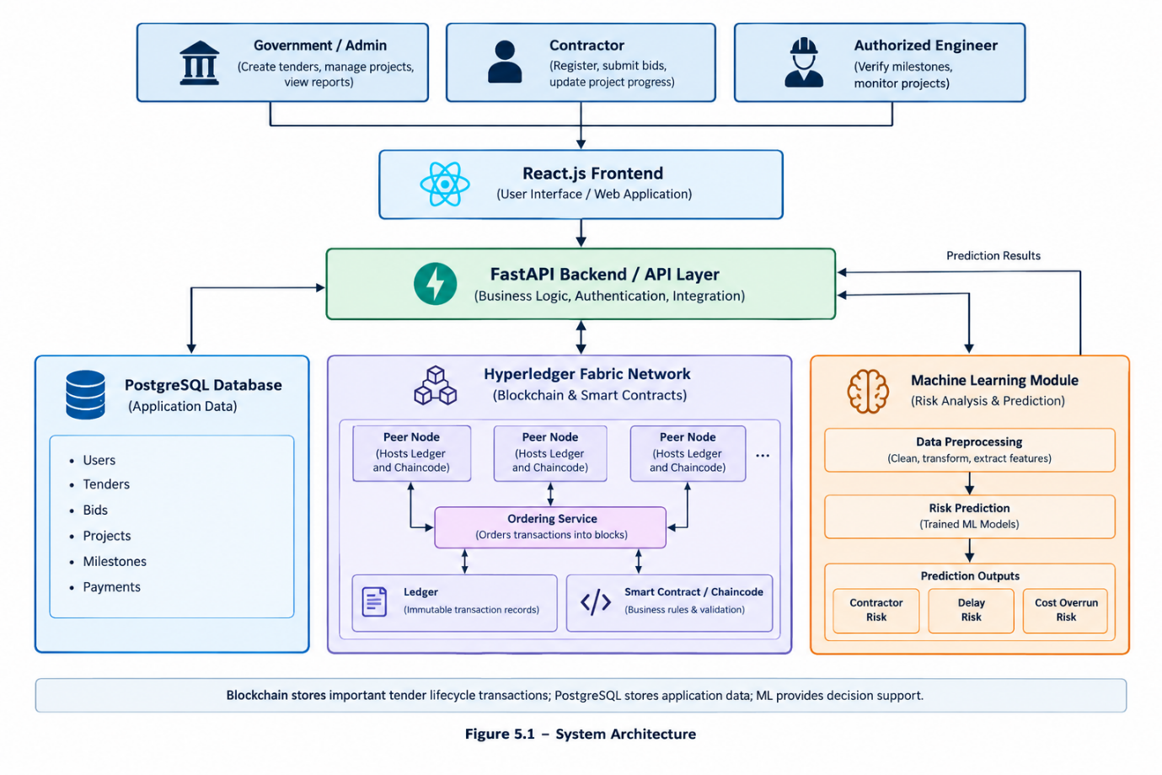
5.2 SYSTEM WORKFLOW
Step 1: Tender Creation
The government official logs in and creates a tender by entering its title, project description, estimated budget, deadline, project duration, eligibility requirements, and other details. The backend validates the information before storing it in the database, and important tender details can also be recorded on the blockchain.

Step 2: Tender Publication
The created tender is published through the system. Registered contractors can view available tender details and check whether they meet the eligibility conditions.
Step 3: Contractor Registration
Contractors register by providing company details, previous experience, completed projects, and performance-related information. These details are stored in the database and used by the machine learning module for risk analysis.
Step 4: Bid Submission
Eligible contractors submit bids before the deadline, including the proposed bid amount, project completion period, technical details, and other required information. The system records the submissions and maintains the relevant transaction history.
Step 5: Bid Validation and Evaluation
Submitted bids are checked against tender requirements. Smart contracts can validate predefined conditions, such as submission deadlines and required information, while contractor history and project data support risk analysis.
Step 6: Machine Learning Prediction
The machine learning module analyzes contractor and project data to predict contractor reliability, project delay, and cost-overrun risks. These predictions support decision-making by authorized officials.
Step 7: Tender Award
Authorized government officials select a contractor based on tender conditions, bid information, and available decision-support information. The final award transaction is recorded on the blockchain to maintain a traceable tender history.
Step 8: Project Execution
After the tender is awarded, the selected contractor begins the project and updates progress through the system according to the defined milestones.
Step 9: Project Monitoring
Government officials monitor milestone completion, reported progress, inspection information, and risk predictions. Machine learning helps identify potential delays and cost overruns during project execution.
Step 10: Milestone Verification
Completed milestones are submitted for verification by an authorized government official or engineer. After reviewing the submitted information, the official updates the milestone status, and the relevant transaction can be recorded on the blockchain.
Step 11: Payment Processing
Payments are linked to verified project milestones. Once the required conditions are satisfied, the payment-related transaction is recorded, and the payment status is updated, connecting project progress, milestone verification, and payment records.
Step 12: Project Completion
After all milestones are completed and final requirements are verified, the project is marked as completed. Important project and payment records remain available for future reference and auditing.
Figure 5.2 System Workflow
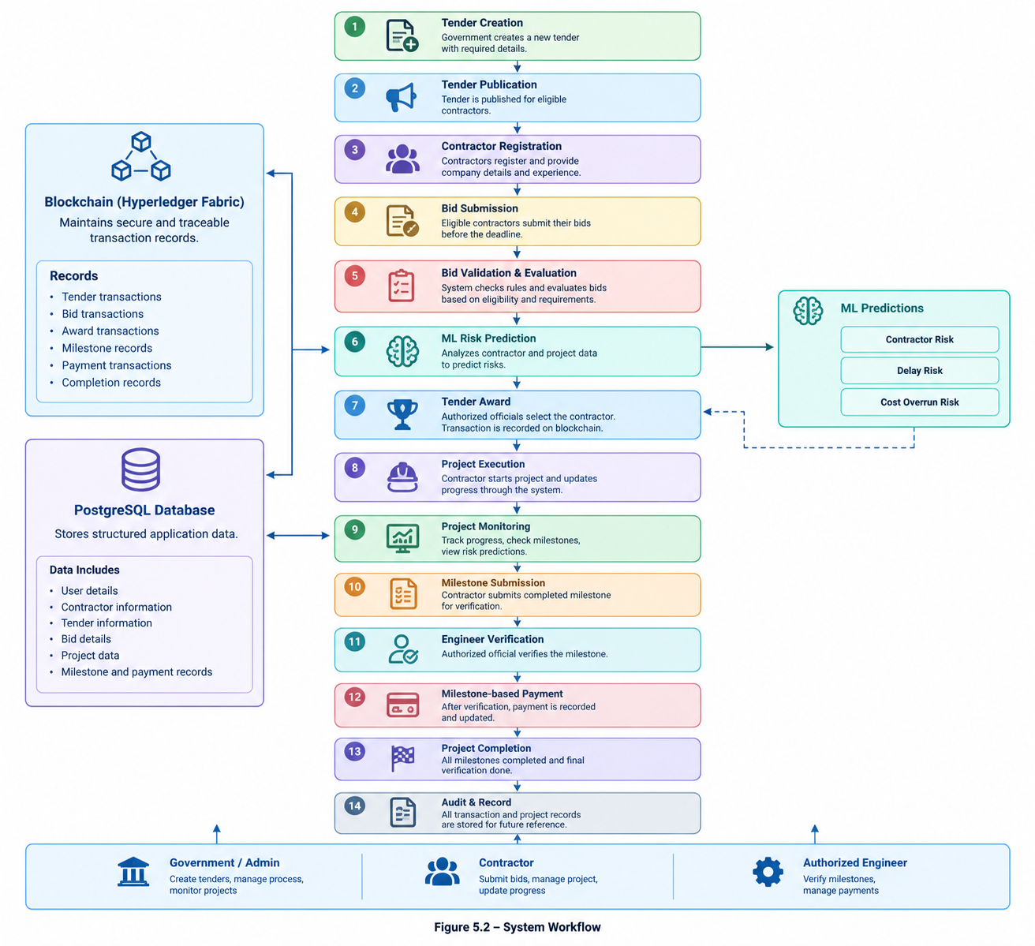

5.3 GOVERNMENT/ADMIN MODULE
The Government/Admin Module enables authorized officials to manage the tender lifecycle, including tender creation, publication, bid review, contractor information, tender awards, and record maintenance.
After a tender is awarded, officials can monitor project progress, review milestones, and view machine learning-based risk predictions to identify projects requiring attention. The module includes government login, tender management, bid viewing and evaluation support, contractor information viewing, tender awarding, project monitoring, milestone verification, payment status monitoring, and audit record viewing.
Final decisions regarding contractor selection and project activities remain with authorized government officials.
5.4 CONTRACTOR MODULE
The Contractor Module allows registered contractors to participate in tenders and manage project activities. Contractors can create profiles containing company details, experience, previous projects, and other required information, view available tenders, and check eligibility.
They can submit bids before deadlines and, after receiving a contract, update project progress and submit milestone information. The module supports contractor registration, profile management, tender viewing, requirement checking, bid submission, bid status viewing, progress updates, milestone submission, payment status viewing, and project completion updates.
It provides a centralized interface for tender participation and project management.

5.5 TENDER MANAGEMENT
The Tender Management Module manages government tenders from creation to award. Officials enter details such as tender ID, title, project description, estimated cost, opening and closing dates, project duration, eligibility requirements, technical qualifications, and other conditions.
Tenders can then be published for eligible contractors. The system maintains statuses such as draft, published, closed, under evaluation, awarded, and completed. Important status changes can be recorded on the blockchain to maintain a traceable tender history.

5.6 BID SUBMISSION AND EVALUATION
The Bid Submission and Evaluation Module manages contractor bids submitted before the tender deadline. The system checks whether required information is provided and whether bids are submitted within the permitted time. Bid details may include proposed cost, expected completion period, technical information, and contractor-related details.
During evaluation, authorized officials can review bids and contractor history, while machine learning provides risk predictions based on available historical data. Smart contracts can validate predefined rules, including submission deadlines and required conditions. Final contractor selection remains with authorized officials, combining automated validation with human decision-making.

5.7 BLOCKCHAIN MODULE
The Blockchain Module uses Hyperledger Fabric to maintain important tender and project transactions in a permissioned network accessible to authorized participants.
It can record tender creation and publication, bid submission, bid evaluation status, tender awards, project milestone updates, milestone verification, payment-related records, and project completion.
PostgreSQL stores regular application data and supports efficient querying, while blockchain maintains important transactions requiring a trustworthy and traceable history. This separation avoids storing large files and unnecessary application data directly on the blockchain.
5.8 SMART CONTRACT MODULE
The Smart Contract Module uses chaincode in Hyperledger Fabric to implement rules and validate blockchain transactions. For example, it can check whether required tender information is available before recording a tender and whether a tender remains open before accepting a bid.
It also manages tender states and permits valid transitions, such as:
Created → Published → Open for Bidding → Closed → Under Evaluation → Awarded → Completed
For milestones, the system can record submitted work as pending verification. After an authorized official verifies it, the status can be updated and the transaction recorded.The module supports tender validation, bid recording, tender status management, award recording, milestone transactions, verification status, payment-related transactions, and project completion. Smart contracts reduce manual transaction recording and ensure consistent execution of predefined rules.

5.9 MACHINE LEARNING MODULE
The Machine Learning Module analyzes historical contractor and project data to identify patterns indicating potential risks. A model is trained using contractor- and project-related features after data preprocessing, and suitable algorithms are tested to select a model with appropriate performance.
The module focuses on three prediction areas:
- Contractor Risk Prediction
- Project Delay Prediction
- Cost Overrun Prediction
Predictions are provided to authorized government officials as decision-support information. The module does not automatically make final tender-award or project-management decisions.
Table 5.1 System Modules and Functions
Module | Main Functions
Government/Admin | Tender creation, management, evaluation and monitoring
Contractor | Registration, tender viewing, bid submission and project updates
Tender Management | Tender creation, publication and status management
Bid Evaluation | Bid validation, comparison and evaluation support
Blockchain | Secure and traceable transaction records
Smart Contract | Rule validation and transaction automation
Machine Learning | Risk prediction and analysis
Project Monitoring | Progress and milestone monitoring
Milestone and Payment | Verification and payment tracking
Audit and Records | Historical transaction and project records

5.9.1 Contractor Risk Prediction
Contractor Risk Prediction analyzes previous contractor performance to identify potential risks using features such as completed projects, delayed projects, cost overruns, contractor experience, project value, and performance history.
The output can be a risk category or probability, depending on the selected machine learning approach. For example, contractors may be classified as Low Risk, Medium Risk, or High Risk, based on the dataset and model used. These predictions support contractor evaluation but should not be the sole basis for selecting or rejecting a contractor.
5.9.2 Project Delay Prediction
Project Delay Prediction identifies the possibility of delays after a tender is awarded and project execution begins. The model can consider planned project duration, current progress, contractor history, project value, previous delays, milestone completion, and other available project features.
For example, if actual progress falls significantly behind planned progress, the system can flag the project for additional monitoring. This helps officials identify potential problems early rather than waiting until the project is significantly delayed.
5.9.3 Cost Overrun Prediction
Cost Overrun Prediction identifies the possibility of actual project expenditure exceeding the planned or estimated cost. The model can consider estimated project cost, bid amount, project duration, material cost, previous cost overruns, contractor performance, project progress, and completed milestones.
The prediction provides an early indication of potential cost-related risks, helping officials monitor high-risk projects more carefully. It supports decision-making without automatically making financial decisions.
Table 5.2 Machine Learning Input Features
Feature | Purpose
Tender Value | Represents the estimated project value
Bid Amount | Represents the contractor's proposed cost
Contractor Experience | Indicates previous experience
Previous Delays | Indicates past delay history
Previous Cost Overruns | Indicates past cost performance
Project Duration | Represents planned completion period
Material Cost | Represents major project cost factors
Current Progress | Used for project monitoring
Milestone Status | Indicates project completion stage
Previous Performance | Represents contractor performance history

5.10 PROJECT MONITORING
The Project Monitoring Module manages projects after tender award, extending the system beyond contractor selection. Contractors can update project progress, while government officials or authorized engineers review progress and verify milestones.
The module displays project start and planned completion dates, current progress, completed and pending milestones, delay indicators, cost information, risk predictions, and verification status. Machine learning analyzes project data to identify potential risks and projects requiring additional monitoring. Thus, the module connects tendering with actual project execution.

5.11 MILESTONE AND PAYMENT MANAGEMENT
The Milestone and Payment Module manages project milestones and related payment records. Projects can be divided into milestones such as foundation work, structural work, electrical work, finishing, and final completion.
After completing a milestone, the contractor submits progress information for verification by an authorized official or engineer.
The process is:
Milestone Created → Work Completed → Contractor Submission → Official Verification → Milestone Approved → Payment Recorded
The corresponding milestone payment process proceeds only after the required verification conditions are satisfied. Important milestone and payment transactions can also be recorded on the blockchain, creating a traceable link between project progress, verification, and payment activities. This improves accountability through clear records of milestone completion and payments.

5.12 AUDIT AND RECORD MANAGEMENT
The Audit and Record Management Module maintains historical information throughout the tender lifecycle. PostgreSQL stores regular application data, while Hyperledger Fabric maintains important transaction records on the blockchain.
Audit information includes tender creation and publication, bid submissions, evaluation status, tender awards, project milestones, verification, payment transactions, and project completion records.
Blockchain provides a traceable history of recorded transactions, supporting audits and helping authorized users understand the sequence of activities throughout the tender and project lifecycle. The module therefore provides a complete view from initial tender creation to final project completion.
5.13 CHAPTER SUMMARY
This chapter described the design and major modules of the proposed Government Tender Lifecycle Management System, covering tender creation, bidding, project execution, and completion.
React.js provides the user interface, FastAPI manages application logic and component communication, PostgreSQL stores structured data, and Hyperledger Fabric maintains important blockchain transactions. Smart contracts implement predefined rules and automate selected blockchain operations.
Machine learning predicts contractor risk, project delays, and cost overruns. Project monitoring and milestone management extend the system beyond tender allocation to support post-award project management.
Overall, the system combines blockchain for secure, traceable records, smart contracts for rule-based processing, and machine learning for risk-based decision support to manage the complete government tender lifecycle.

CHAPTER 6
IMPLEMENTATION AND RESULTS

6. IMPLEMENTATION AND RESULTS
The proposed Government Tender Lifecycle Management System is implemented using a combination of web technologies, database management, blockchain, smart contracts, and machine learning. The system is designed to manage the tender process from tender creation and bid submission to project monitoring, milestone verification, payment recording, and project completion. React.js is used for developing the user interface, FastAPI is used for the backend services, and PostgreSQL is used for storing application data. Hyperledger Fabric is used to maintain important tender lifecycle transactions on a permissioned blockchain network, while machine learning is used to provide risk predictions related to contractors and projects.

6.1 DATABASE IMPLEMENTATION
PostgreSQL is used as the relational database for storing the application data of the proposed system. The database maintains information related to users, contractors, tenders, bids, projects, milestones, payments, and machine learning predictions. The database is mainly used for regular application operations, while important lifecycle transactions are additionally recorded on the Hyperledger Fabric blockchain.
The database is designed to maintain relationships between the different entities involved in the tender lifecycle. For example, a tender can receive multiple bids, a selected bid can result in a project, and a project can contain multiple milestones and payment records.
Table 6.1 – Database Tables and Purpose
Table | Purpose
User | Stores government and contractor user information
Contractor | Stores contractor profile and experience details
Tender | Stores tender details and requirements
Bid | Stores contractor bid information
Project | Stores awarded project details
Milestone | Stores project milestone information
Payment | Stores milestone-based payment records
Risk Prediction | Stores machine learning prediction results
The database helps the application retrieve and update information efficiently. It also provides the supporting data required by the machine learning module for generating risk predictions.

6.2 BACKEND IMPLEMENTATION
FastAPI is used to develop the backend, which connects the React frontend, PostgreSQL database, machine learning module, and Hyperledger Fabric network.
The backend provides APIs for government officials, contractors, and authorized engineers. These APIs receive frontend requests, validate information, perform operations, and return results.
Major operations include user registration and authentication, contractor management, tender creation and retrieval, bid submission and evaluation, tender award, project creation, milestone management, machine learning predictions, payment recording, and blockchain transaction handling.
By separating application logic from the user interface and database, the backend improves maintainability and extensibility.

6.3 FRONTEND IMPLEMENTATION
React.js is used to develop the frontend, with interfaces based on user roles.
The government or administrator interface supports tender creation and publication, bid review, contractor information, project monitoring, milestone verification, and payment tracking.
The contractor interface allows users to register, view available tenders, submit bids, check bid status, update project progress, and view milestone and payment information.
The major screens include:
- Login Page
- Government Dashboard
- Tender Creation Page
- Tender Listing Page
- Bid Submission Page
- Bid Evaluation Page
- Project Monitoring Page
- Milestone Verification Page
- Payment Tracking Page
- Machine Learning Risk Prediction Page
- Audit and Transaction History Page
Screenshots of the completed interfaces can be added after implementation.

Figure 6.1 – Government Dashboard
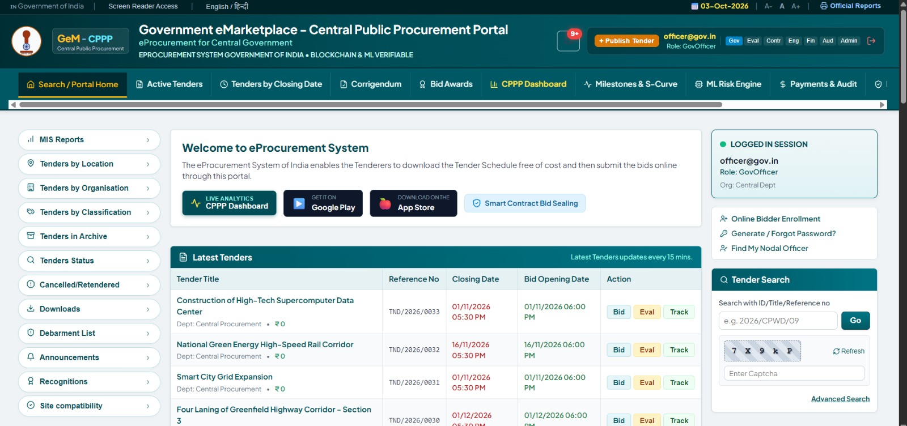

Figure 6.2 – Tender Management Interface
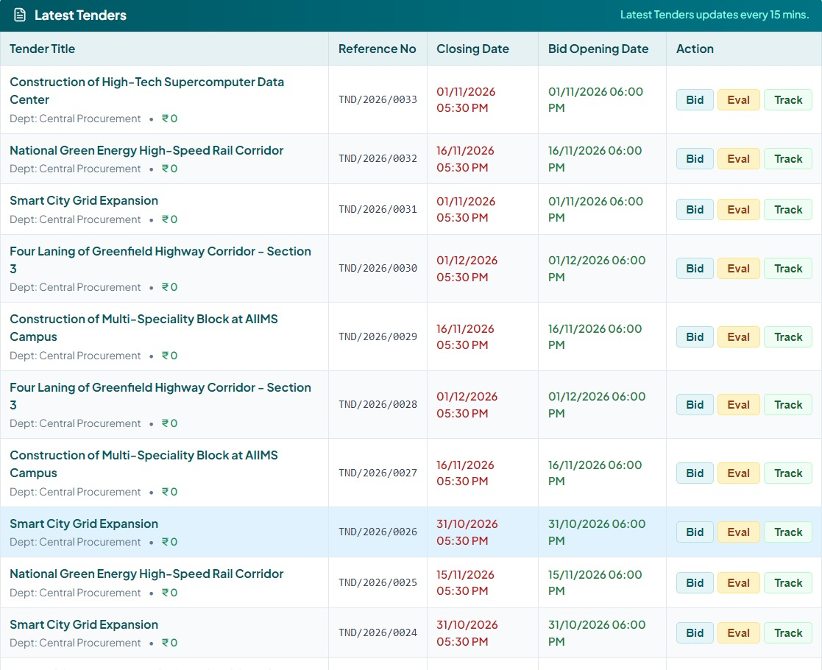

6.4 HYPERLEDGER FABRIC IMPLEMENTATION
Hyperledger Fabric serves as the permissioned blockchain layer, allowing authorized organizations to participate and maintaining a traceable history of important tender lifecycle transactions.
Smart contracts are deployed as chaincode and invoked by applications to interact with the ledger. Fabric peers host the ledger and chaincode, while the ordering service organizes transactions into blocks before they are committed.
Important operations recorded on the blockchain may include:
- Tender creation and publication
- Bid submission and evaluation status
- Tender award
- Milestone submission and verification
- Payment authorization or recording
- Project completion
PostgreSQL stores regular application data, while Hyperledger Fabric maintains important lifecycle records requiring a trusted and traceable history.

Table 6.2 – Blockchain Transactions
Transaction | Purpose
CreateTender | Creates a new tender record
PublishTender | Publishes a tender for bidding
SubmitBid | Records a contractor bid
EvaluateBid | Records bid evaluation information
AwardTender | Records the selected contractor
CreateMilestone | Creates a project milestone
VerifyMilestone | Records milestone verification
RecordPayment | Records milestone-based payment
CompleteProject | Records project completion

The actual transaction names can be modified according to the chaincode implemented in the project.

6.5 SMART CONTRACT IMPLEMENTATION
Smart contracts are implemented using Hyperledger Fabric chaincode to enforce predefined rules for tender lifecycle transactions. They validate transaction conditions before allowing state changes. For example, bids can only be submitted while a tender is open, and milestone payments can only be recorded after verification.
The major smart contract operations are:
- Create Tender: CreateTender() validates tender information and creates a new tender.
- Publish Tender: PublishTender() changes the tender status from created to published.
- Submit Bid: SubmitBid() records a contractor's bid against the corresponding tender.
- Award Tender: AwardTender() records the tender award after evaluation.
- Verify Milestone: VerifyMilestone() records the verification of completed milestone work.
- Record Payment: RecordPayment() records payment associated with an approved milestone.
The general tender status flow is:
Created → Published → Open for Bidding → Closed → Under Evaluation → Awarded → Completed
Smart contracts reduce manual updates and ensure consistent application of predefined rules.

6.6 MACHINE LEARNING IMPLEMENTATION
Machine learning supports decision-making by analyzing contractor and project information to identify potential risks.
The model may use features such as tender value, bid amount, contractor experience, previous project delays and cost overruns, project duration, material cost, previous performance, current progress, and milestone status.
Before training, the data is preprocessed by handling missing values, converting data into a suitable format, selecting relevant features, and splitting the dataset into training and testing sets.
The module supports three prediction areas:
6.6.1 Contractor Risk Prediction
The model analyzes contractor performance and related information to estimate risk, classified as Low Risk, Medium Risk, or High Risk. The prediction supports government officials during evaluation but does not automatically determine contractor selection.
6.6.2 Project Delay Prediction
The model analyzes planned duration, current progress, previous delays, contractor performance, and milestone status to identify projects that may require closer monitoring.

6.6.3 Cost Overrun Prediction
The model considers estimated project cost, bid amount, material cost, project duration, previous cost overruns, and project progress to identify the possibility of exceeding the estimated cost.

6.7 MACHINE LEARNING RESULTS
The trained and tested machine learning model will be evaluated using suitable performance measures. For classification models, accuracy, precision, recall, and F1-score can be used. A confusion matrix can also be included to present the classification results.
Table 6.3 – Machine Learning Model Performance
Evaluation Measure | Result
Accuracy | [To be added]
Precision | [To be added]
Recall | [To be added]
F1-Score | [To be added]

The actual values should be added only after training and testing the final model.
The prediction results can be displayed in the system dashboard so that authorized users can view the identified project or contractor risks.
Figure 6.3 – Machine Learning Prediction Dashboard
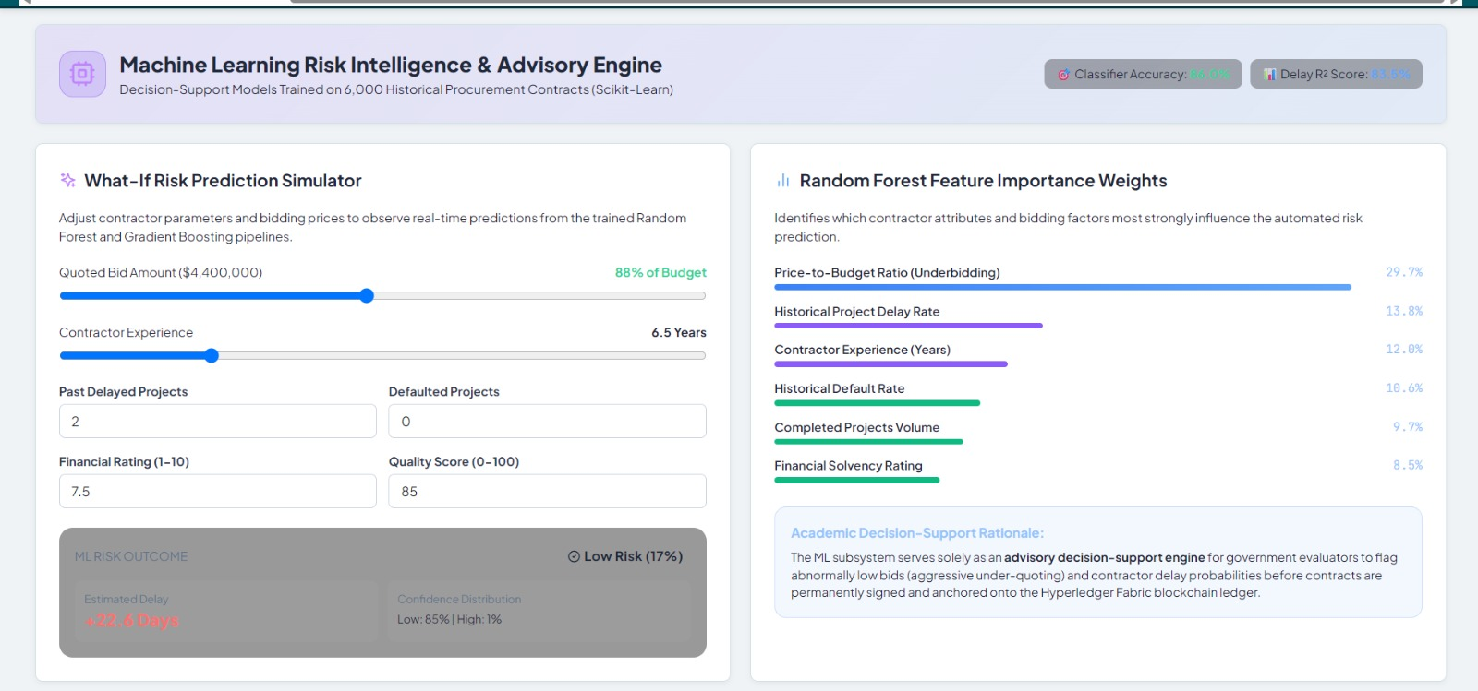

6.8 PROJECT MONITORING IMPLEMENTATION
The proposed system supports post-award project monitoring, tracking progress from contractor selection to project completion.
Contractors submit project progress and milestone information, which authorized engineers review and verify.
The monitoring process follows:
Project Award → Milestone Creation → Work Execution → Progress Submission → Engineer Verification → Risk Analysis → Milestone Approval → Payment Recording
The module maintains planned and actual progress, milestone status, verification status, and payment status, providing a continuous project record from award to completion.

6.9 MILESTONE AND PAYMENT IMPLEMENTATION
The system uses milestone-based monitoring to connect project progress with payment records. Milestones are defined according to project requirements, and contractors submit progress information after completing each milestone. An authorized engineer then verifies the submitted work.
The process follows:
Milestone Created → Work Completed → Progress Submitted → Engineer Verification → Milestone Approved → Payment Recorded
Important milestone verification and payment transactions can be recorded on the blockchain, providing a traceable history of the project payment process.

6.10 SYSTEM TESTING
Testing is performed to verify whether the different modules of the proposed system work according to their intended functions. Each major operation is tested using valid and invalid inputs.
Table 6.4 – System Test Cases
Test Case | Expected Result | Status
Government login | User successfully logged in | Pass
Contractor registration | Contractor registered successfully | Pass
Create tender | Tender created successfully | Pass
Publish tender | Tender made available for bidding | Pass
Submit bid | Bid recorded successfully | Pass
Invalid bid submission | Invalid bid rejected | Pass
Award tender | Tender award recorded | Pass
Create milestone | Milestone created successfully | Pass
Verify milestone | Milestone status updated | Pass
ML prediction | Risk prediction generated | Pass
Record payment | Payment record created | Pass
Complete project | Project marked as completed | Pass

6.11 RESULTS AND DISCUSSION
The proposed system integrates blockchain, smart contracts, machine learning, database management, and web technologies to manage the complete government tender lifecycle, from tender creation and bid submission to project execution, milestone verification, payment recording, and completion.
Blockchain provides traceable transaction records, while smart contracts enforce predefined rules. Machine learning predicts contractor and project-related risks, and project monitoring supports progress tracking after contract award.
The implementation will be evaluated based on the successful execution of system modules, blockchain transactions, machine learning predictions, project monitoring functions, and system test cases.

6.12 CHAPTER SUMMARY
This chapter presented the implementation approach for the proposed Government Tender Lifecycle Management System. React.js provides the frontend, FastAPI handles backend services, PostgreSQL stores application data, Hyperledger Fabric maintains blockchain transaction records, and machine learning supports risk prediction.
The implementation covers tender management, bid submission, smart contract operations, contractor and project risk prediction, project monitoring, milestone verification, and payment recording. Testing will verify individual modules and the complete workflow. Final implementation results and performance values will be added after system development and testing are completed.

CHAPTER 7
APPENDIX-I
A.1 INTRODUCTION
This appendix provides supporting technical information for implementing the proposed Government Tender Lifecycle Management System. While the main chapters describe the system design, modules, implementation, and results, this appendix presents additional implementation details.
It covers the database structure, backend API operations, smart contract functions, machine learning implementation, sample predictions, and other relevant technical details.

A.2 DATABASE STRUCTURE
PostgreSQL stores the application's data in separate tables for users, contractors, tenders, bids, projects, milestones, payments, and machine learning predictions.
The major database tables are:
- User
- Contractor
- Tender
- Bid
- Project
- Milestone
- Payment
- Risk Prediction
The database maintains information throughout the tender lifecycle, including tender creation, bid submission, project monitoring, milestone verification, payment tracking, and risk prediction.

A.3 BACKEND API DETAILS
The backend of the proposed system is developed using FastAPI. The backend APIs provide communication between the React frontend, PostgreSQL database, machine learning module, and blockchain components.
Table A.1 – Major Backend APIs
API Operation | Purpose
User Registration | Registers a new user
User Login | Authenticates a user
Create Tender | Creates a new tender
Get Tenders | Retrieves available tenders
Submit Bid | Submits a contractor bid
Evaluate Bid | Processes bid evaluation
Award Tender | Records the tender award
Create Project | Creates an awarded project
Add Milestone | Creates a project milestone
Verify Milestone | Updates milestone verification
Record Payment | Records milestone payment
Generate Prediction | Generates ML-based risk prediction

A.4 SMART CONTRACT FUNCTIONS
Hyperledger Fabric smart contracts are used to define the business rules for important tender lifecycle transactions. In Hyperledger Fabric, smart contracts define the executable business logic, while chaincode is used to package and deploy related smart contracts.
The proposed system contains functions corresponding to the major operations of the tender lifecycle.
Table A.2 – Smart Contract Functions
Function | Description
CreateTender() | Creates a new tender
PublishTender() | Publishes a tender
SubmitBid() | Records a contractor bid
EvaluateBid() | Records the bid evaluation
AwardTender() | Records the tender award
CreateMilestone() | Creates a project milestone
VerifyMilestone() | Records milestone verification
RecordPayment() | Records payment information
CompleteProject() | Records project completion

These functions help maintain the state of important tender and project transactions on the blockchain. The final function names and operations will depend on the actual chaincode implementation.

A.5 MACHINE LEARNING IMPLEMENTATION
The machine learning component is used to analyze contractor and project-related information and generate risk predictions. The implementation includes data preprocessing, feature selection, model training, model testing, and prediction.
The main input features considered by the system include:
- Tender value
- Bid amount
- Contractor experience
- Previous delays
- Previous cost overruns
- Project duration
- Material cost
- Previous performance
- Current project progress
- Milestone status
The machine learning component is mainly used to provide decision support for identifying possible contractor and project-related risks. The final dataset, preprocessing techniques, selected model, and model performance results will be documented based on the actual implementation.

A.6 SAMPLE PREDICTION
A sample prediction can be included to demonstrate how the machine learning model is used by the application. The prediction may provide information about contractor risk, project delay risk, or cost overrun risk.
Table A.3 – Sample Risk Prediction
Input | Example Value
Tender Value | [Actual value]
Bid Amount | [Actual value]
Previous Delays | [Actual value]
Previous Cost Overruns | [Actual value]
Project Duration | [Actual value]
Current Progress | [Actual value]
Milestone Status | [Actual value]
Predicted Risk | [Actual result]
A.7 IMPORTANT IMPLEMENTATION DETAILS
The following supporting information can also be included in this appendix after the implementation is completed:
- Database schema and table details
- API request and response examples
- Smart contract transaction details
- Machine learning preprocessing steps
- Selected machine learning model
- Model configuration
- Sample blockchain transaction details
- Sample project monitoring data
- Sample milestone verification details
- Sample payment transaction details
This appendix provides additional technical information about the implemented system without including lengthy source code. It supports the main chapters by providing details that may be useful for understanding the database, APIs, blockchain functions, and machine learning components of the proposed system.

CHAPTER 8
APPENDIX-II

B.1 INTRODUCTION
This appendix contains additional screenshots and output results obtained from the implementation of the proposed Government Tender Lifecycle Management System. These screenshots provide visual evidence of the different modules and functionalities developed as part of the project.
The screenshots included in this appendix cover the user interface, tender management, bid submission, machine learning predictions, blockchain transactions, project monitoring, milestone verification, and payment tracking.

B.2 LOGIN SCREEN
The login screen provides access to the system for authorized users. Based on the user role, the system provides the appropriate functionalities.
Figure B.1 – Login Screen
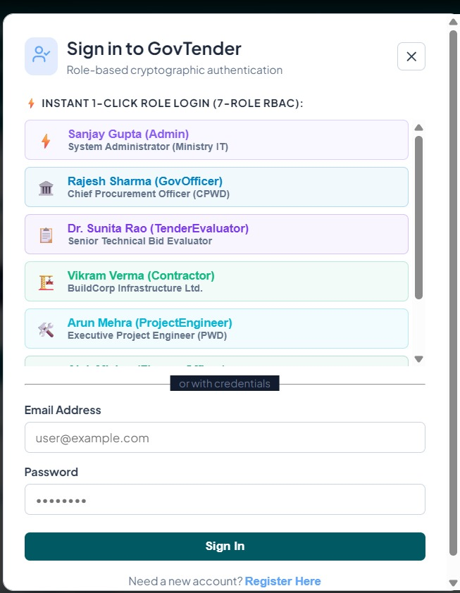

B.3 GOVERNMENT DASHBOARD
The government dashboard provides access to the major administrative functions of the system. Government officials can create tenders, view submitted bids, monitor awarded projects, verify milestones, and view relevant records.
Figure B.2 – Government Dashboard

B.4 TENDER CREATION
The tender creation page allows authorized government users to enter the required tender information. The information may include tender title, description, estimated cost, project duration, opening date, closing date, and eligibility requirements.
Figure B.3 – Tender Creation Screen
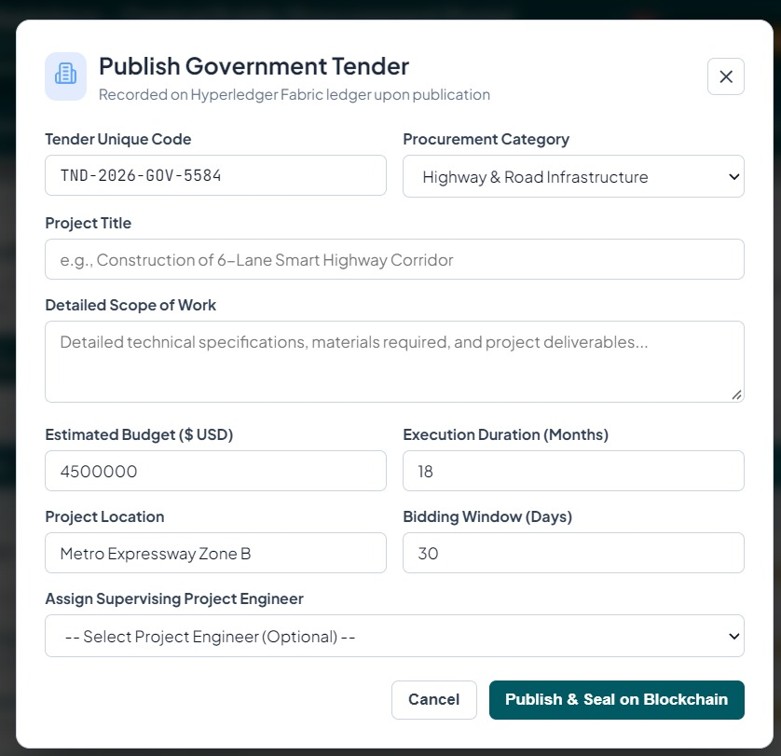
B.5 TENDER LIST
The tender listing page displays the tenders available in the system along with their current status. Contractors can use this page to view tenders that are open for bidding.
Figure B.4 – Tender Listing Screen

B.6 BID SUBMISSION
The bid submission page allows a registered contractor to submit a bid for an available tender. The submitted information may include bid amount, proposed completion period, and technical details.
Figure B.5 – Bid Submission Screen
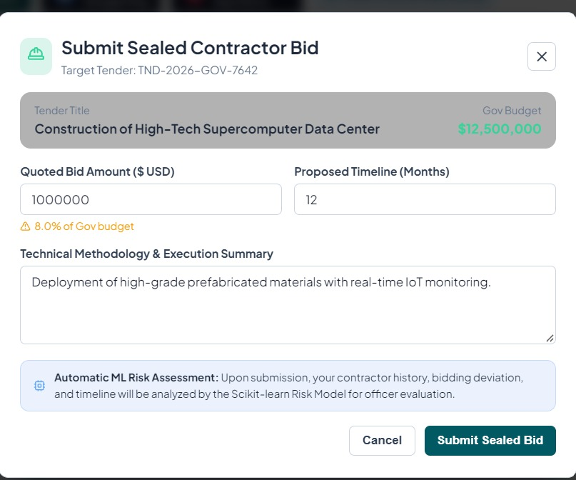
B.7 BID EVALUATION
The bid evaluation screen provides government officials with information required for evaluating submitted bids. Contractor information, bid details, previous performance information, and machine learning risk predictions can be displayed to support the evaluation process.
Figure B.6 – Bid Evaluation Screen
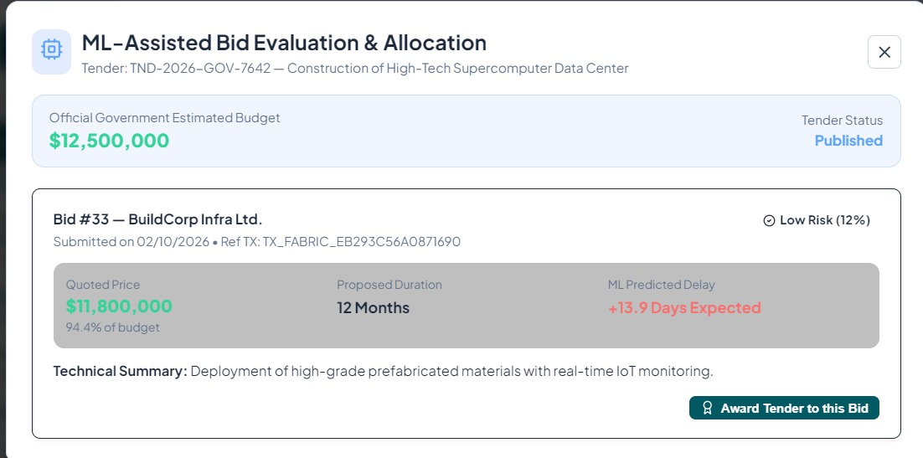

B.8 BLOCKCHAIN TRANSACTION
Important tender lifecycle activities are recorded through the Hyperledger Fabric blockchain. A blockchain transaction output can be included in this section to demonstrate that the relevant transaction was successfully submitted and recorded.
Examples of transactions include:
- Tender creation
- Bid submission
- Tender award
- Milestone verification
- Payment recording
- Project completion
Figure B.7 – Blockchain Transaction Output
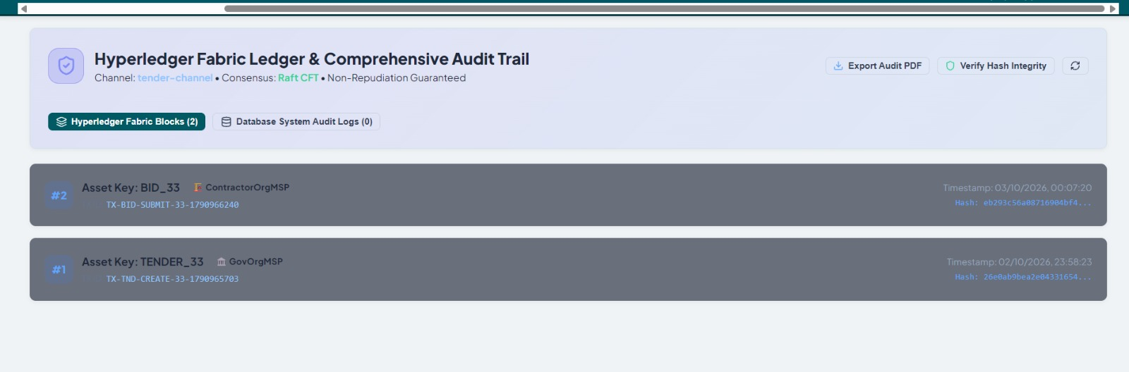
B.9 SMART CONTRACT OUTPUT
The smart contract or chaincode is responsible for processing important tender lifecycle operations according to predefined rules.
The output of a successful smart contract transaction can be included here to demonstrate the execution of the implemented chaincode.
Figure B.8 – Smart Contract Transaction Output
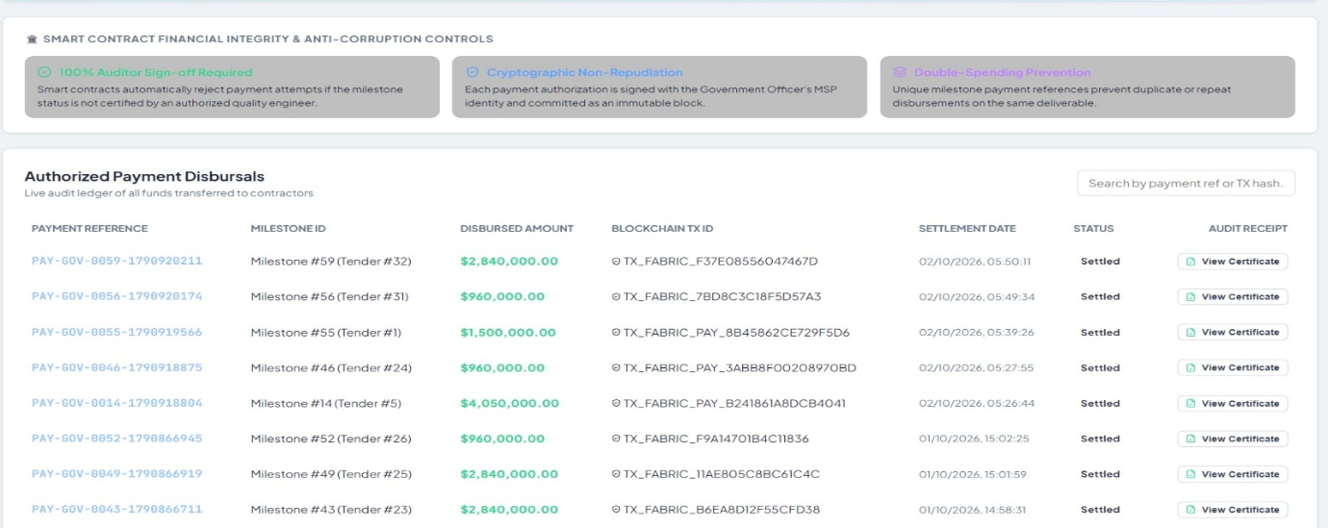

B.10 MACHINE LEARNING PREDICTION
The machine learning module provides risk predictions based on contractor and project-related information.
The prediction screen may display:
- Contractor Risk
- Project Delay Risk
- Cost Overrun Risk
The actual prediction generated by the implemented model should be shown in this section.
Figure B.9 – Machine Learning Risk Prediction
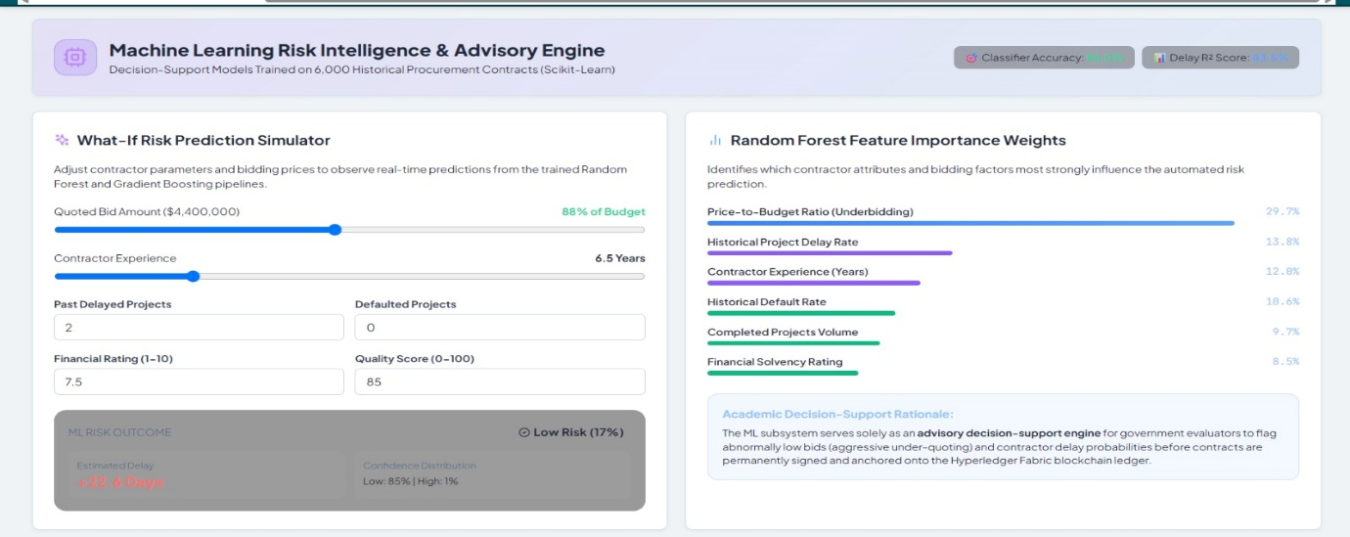
B.11 PROJECT MONITORING AND MILESTONE VERIFICATION
The project monitoring screen provides information about the progress of an awarded project. It can display planned progress, actual progress, milestone status, verification status, and identified project risks.
The milestone verification screen allows an authorized engineer or government official to review submitted project progress and verify whether the required milestone has been completed.
Figure B.10 – Project Monitoring and Milestone Verification Screen
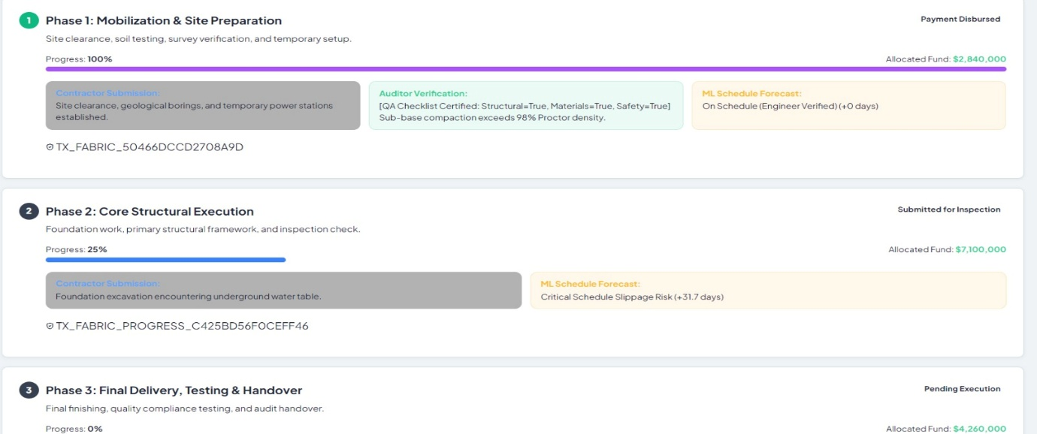

B.12 AUDIT AND TRANSACTION HISTORY
The audit section provides a historical view of important activities performed during the tender lifecycle. It can include tender creation, bid submission, tender award, milestone verification, payment recording, and project completion.
Figure B.11 – Audit and Transaction History
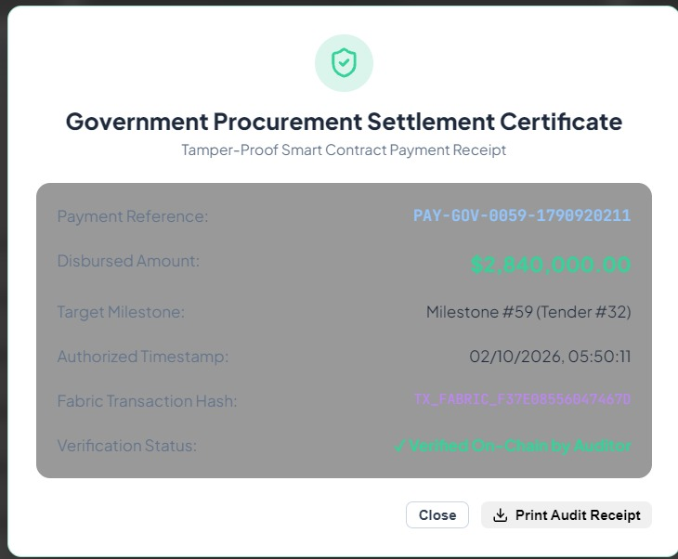
B.16 SYSTEM TESTING OUTPUT
The final testing results of the system can be included in this section. The screenshots may show successful execution of the major modules and transactions.
Table B.1 – Final System Testing Summary
Module | Test Result
User Authentication | Pass
Tender Management | Pass
Bid Submission | Pass
Bid Evaluation | Pass
Blockchain Transaction | Pass
Smart Contract | Pass
ML Prediction | Pass
Project Monitoring | Pass
Milestone Verification | Pass
Payment Tracking | Pass
Project Completion | Pass

B.17 APPENDIX SUMMARY
This appendix presented the supporting screenshots and output results of the Government Tender Lifecycle Management System. The screenshots demonstrate the working of the major modules, including tender management, bid submission, blockchain transactions, machine learning predictions, project monitoring, milestone verification, and payment tracking.
The final version of this appendix should contain screenshots taken from the actual implemented system and should be updated after completing the development and testing process.

CHAPTER 9
CONCLUSION AND FUTURE ENHANCEMENT

9.1 CONCLUSION
The proposed project, Government Tender Lifecycle Management System using Blockchain and Machine Learning, focuses on improving the management and monitoring of government tenders from the initial tender creation stage to project completion. The system is designed to address some of the limitations of conventional tender management by providing a continuous and traceable process that includes tender publication, bid submission, evaluation, tender award, project execution, milestone verification, payment tracking, and project completion.
The system combines different technologies to perform different functions. React.js is used to provide the user interface, while FastAPI manages the backend services and communication between the different components. PostgreSQL is used to store application data related to users, contractors, tenders, bids, projects, milestones, and payments. Hyperledger Fabric is used as a permissioned blockchain platform for maintaining important tender lifecycle transactions. Smart contracts are used to apply predefined rules to operations such as tender management, bid submission, tender award, milestone verification, and payment recording.
Machine learning is included as a decision-support component of the system. Contractor and project-related information can be analyzed to identify possible risks such as contractor risk, project delay risk, and cost overrun risk. These predictions can help authorized officials identify projects that may require closer monitoring. The machine learning output is intended to support decision-making rather than automatically replace the decisions of government officials.
One of the main aspects of the proposed system is that it extends the tendering process beyond contractor selection. After a tender is awarded, the project can continue to be monitored through milestones, progress updates, verification, and payment records. By combining blockchain-based record management with machine learning-based risk prediction, the proposed system provides a structured approach for managing the complete tender lifecycle and improving traceability, accountability, and project monitoring.

9.2 FUTURE ENHANCEMENT
The proposed system can be further improved by integrating additional technologies and real-world data sources. The following enhancements can be considered in future versions of the system.
9.2.1 Integration with Real Government E-Procurement Platforms
The system can be integrated with existing government e-procurement platforms to obtain real tender and contractor information. This can reduce manual data entry and allow the system to work with real-world tender data.

9.2.2 Larger Real-World Dataset
The machine learning component can be improved by using a larger dataset containing historical tender, contractor, project, delay, cost, and payment information. A larger and more representative dataset can provide better training and evaluation of prediction models.
9.2.3 Advanced Machine Learning Models
Additional machine learning algorithms can be evaluated to improve the prediction of project delays, cost overruns, and contractor performance. Model selection can be based on the type and quality of available data and the performance observed during testing.
9.2.4 Mobile Application
A mobile application can be developed for contractors, engineers, and government officials. This can allow users to submit project updates, verify milestones, and monitor project information using mobile devices.
9.2.5 Real-Time Project Monitoring
Future versions can include real-time project monitoring using IoT devices, GPS information, photographs, or other project-related data sources. Such information could provide additional inputs for project progress monitoring and risk prediction.
9.2.6 Multi-Department Blockchain Network
The blockchain network can be extended to include multiple government departments and authorized organizations. This can allow different departments to share relevant tender and project records through a permissioned blockchain network.
9.2.7 Automated Document Verification
Future versions can include automated verification of contractor certificates, licenses, financial documents, and other required tender documents. This can reduce the amount of manual verification required during the tender process.
9.2.8 Improved Audit and Reporting
The system can be extended with advanced reporting and visualization features for analyzing tender history, contractor performance, project progress, payments, and risk predictions. This can help authorized users obtain a clearer view of the complete project lifecycle.

REFERENCES

[1] D. Mali, D. Mogaveera, P. Kitawat, and M. Jawwad, “Blockchain-based e-Tendering System,” in 2020 4th International Conference on Intelligent Computing and Control Systems (ICICCS), Madurai, India, 2020, pp. 357–362, doi: 10.1109/ICICCS48265.2020.9120890.
[2] X. Gong, X. Tao, M. Das, Y. Liu, and J. Cheng, “Blockchain-based E-tendering Evaluation Framework,” in Proceedings of the 38th International Symposium on Automation and Robotics in Construction (ISARC 2021), Dubai, UAE, 2021, pp. 115–121, doi: 10.22260/ISARC2021/0018.
[3] S. Ahmadisheykhsarmast, S. G. Senji, and R. Sönmez, “Decentralized tendering of construction projects using blockchain-based smart contracts and storage systems,” Automation in Construction, vol. 151, article 104900, 2023, doi: 10.1016/j.autcon.2023.104900.

